**10 Highly Effective KS1 And KS2 Place Value Games** [**https://thirdspacelearning.com/blog/ks1-ks2-place-value-games/**](https://thirdspacelearning.com/blog/ks1-ks2-place-value-games/)

May 6, 2020

**If it’s time for place value games and activities, it must be the start of a brand new academic year. From Year 1 to Year 6 you know it’s September when every maths lesson you pass is teaching KS1 and KS2 pupils the all-important concept of place value. However enthusiastic you are as a teacher we know that teaching this, every year, can feel a bit stale after a while, as you search for a new way to embed the concepts of ones, tens, hundreds, thousands and onwards.**

So we’re here to help.

Here are 10 of our favourite and most [fun and engaging maths](https://thirdspacelearning.com/blog/making-maths-fun-or-engaging/) place value games and activities for KS1 and KS2.

* Sorting and Matching Place Value Game
* Odd One Out Place Value Game
* Classroom Birthdays Place Value Game
* Ten-Sided Dice Place Value Game
* Hula Hoop Place Value Game
* Line Up Place Value Game
* Passing Practice Place Value Game
* Roman Numeral Football Kits Place Value Game
* Delightful Darts Place Value Game
* NEW FOR 2019: Round the Dice Place Value Game

**Place Value Game #1: Sorting and Matching**

*This sorting and matching place value activity is perfect for KS1 pupils, particularly Year 1.*

It’s always good to start off with [concrete manipulatives](https://thirdspacelearning.com/blog/maths-manipulatives-primary-maths-mastery-free-resource/) to introduce any unit of work – and this one is no different!

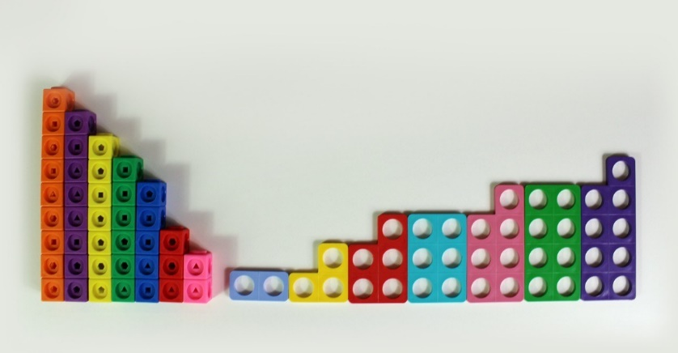The first step is to dig the multi-link cubes out of the cupboard, and after this, ask the children to make sticks of cubes of varying length – from one cube up to ten cubes long. You can then ask the children to arrange the sticks from smallest to largest.

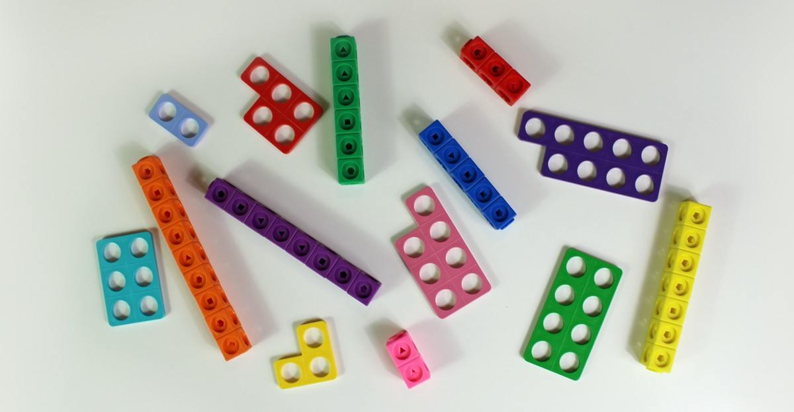Next, ask the children to step back from the table. Jumble up the sticks and mix in some Numicon shapes (or bags with varying amounts of counters in them).

One of the simplest KS1 place value games there is!

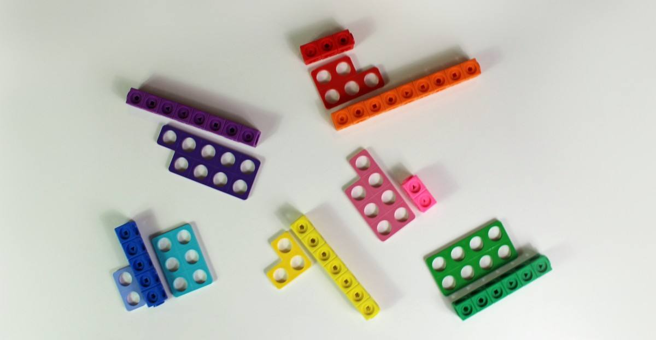Now, it’s time for the children to match the various representations of numbers with its corresponding mathematical representation. You could ask them to do this, or simply tell them to match the various objects as they wish (they might match a stick of six green multi-link cubes with the Numicon shape for eight, because they’re both green).

Depending on how your pupils group the various objects will give you a good indication of any gaps in maths that may need to be filled. Mistakes can happen!

**Place value activities – Extension task for Sorting and Matching**

To really test the children you could ask them to then sort the numbers into two groups: odd numbers and even numbers. (Using Numicon shapes makes it much easier for children to visualise and identify odd numbers.)

**Place Value Game #2: Odd One Out**

*This KS1 place value game should be played with some tact, especially with younger pupils!*

Firstly, arrange the children into groups of various sizes – a group of four, a group of five, a group of seven, a group of eight… Ask them to count how many people are in their group, and then count how many people are in the other groups too.

Next, ask each group to sit down in a line in **pairs** (you could make it a race – which group can sit down the quickest?). Ask the children: can you notice a problem for any of our groups’ lines?

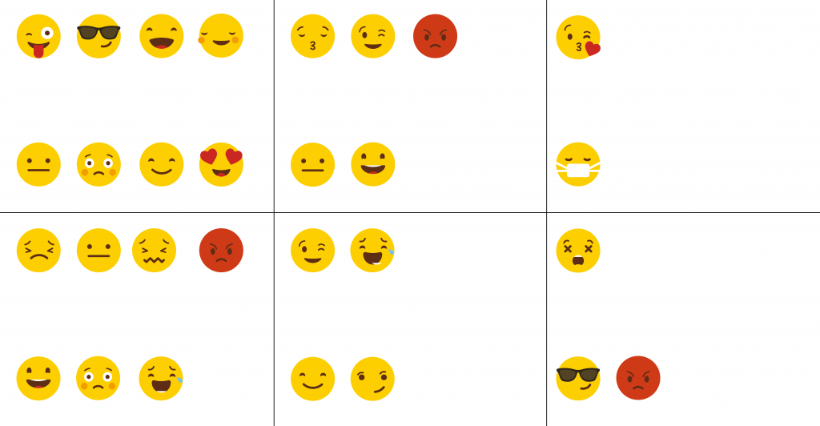

*Line up the children in pairs for this place value game (emojis from FreePik.com)*

Then ask the children to count out the number of children in the groups that have an ‘odd one out’. Hopefully they will notice that the groups of four, six and eight are sat in perfect pairs, but the groups of three, five and seven have an extra person each time. You could reinforce the point by representing the number in each group with a Numicon shape.

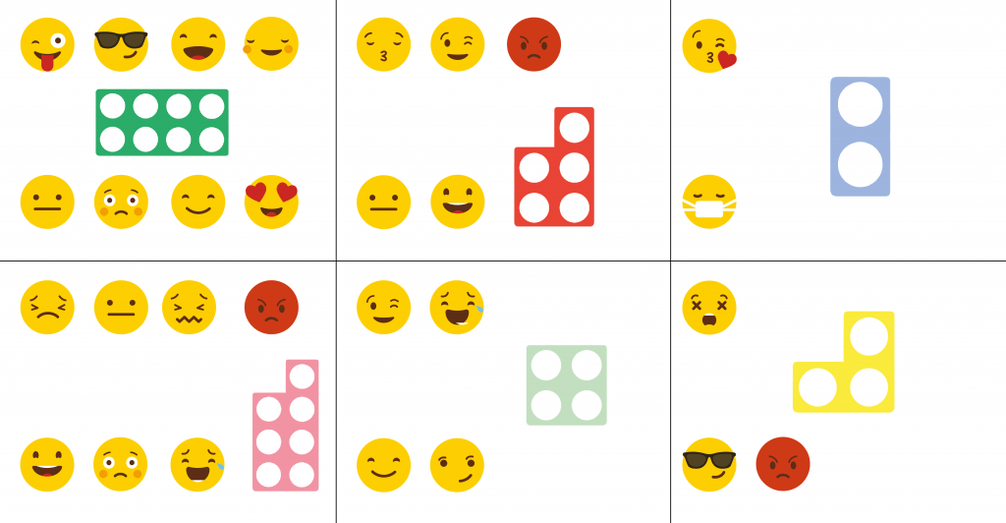R*ecreate pupils’ place value positions with numicon (emojis from FreePik.com)*

This is a simple yet effective Year 1/Year 2 interactive place value game, giving pupils a chance to interact with their classmates whilst learning.

**Place Value Game #3: Classroom Birthdays**

*A number most, if not all, children manage to remember - birthdays are an obvious cue for more place value activities.*

This activity begins by splitting the class into equal groups or teams.

Start by asking the children which month they were born in and equating that month to its number value: January is 1, February is 2 and so on. Then ask the children to tell the other people in their group when they were born – they could even write out their date of birth in its numerical form. For example, 1/11/2011.  
You could ask the children to group themselves into children who were born in an odd-numbered year and even-numbered year, odd-numbered months and even-numbered months, then on odd-numbered days and even-numbered days.  
Depending on the depth you are going into with regards to properties of number with your class, they could organise themselves into those whose months or day numbers fall into certain times tables, or other number properties, like square, cube or prime numbers.  
Next, you could get the groups to organise themselves in age order, from youngest to oldest (call it a race to speed them up). Then, finally have the whole class come together and – using the knowledge from each group – sort themselves into age order!

**This is one place value game that will be relevant year after year and can be used across primary school in KS1 and KS2!**

**Place Value Game #4: The Ten-Sided Dice Rounding Game**

*This sort of simple dice-based place value game is great for Year 1, and can be modified and extended for use with older KS1 and KS2 pupils.*

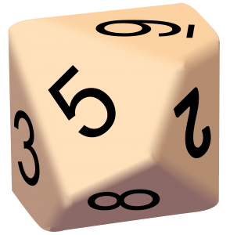If you don’t already have ten-sided dice it could be a smart purchase as they can be handy at different points throughout the year (especially for random number generation).

The first step in this place-value activity is to split the children into **pairs or triplets.**

If they’re in a pair, one child gets a point each time 1, 2, 3, 4 or 10 is rolled (as they’re the ‘rounding down’ person), the other child gets a point each time 5, 6, 7, 8 or 9 is rolled (they’ll be the ‘rounding up’ person).

If there are three children instead of two, the third can be the score-keeper or referee and then they can rotate the roles.

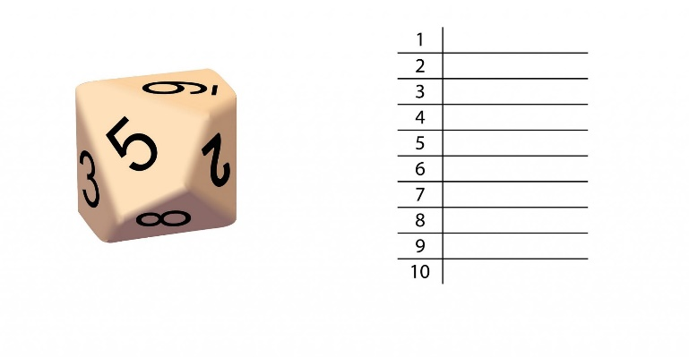

Have the children roll the die and write down each time someone gets a point. Do this ten times; get the most and you’ve won.

**Place Value Game #5: It’s Time to Use The Hula Hoops!**

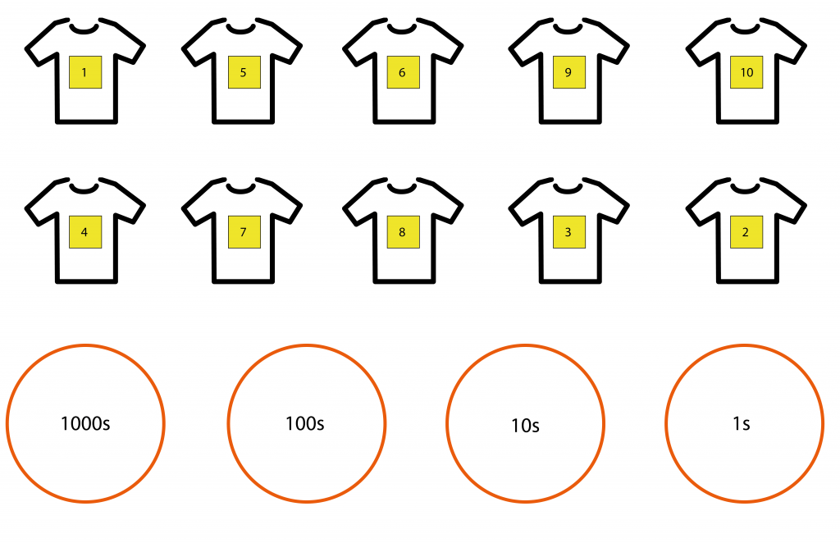*The following lower KS2 place value activity could be used as a starter, an active maths break, or a fantastic warm-up at the beginning of a PE session.*  
  
Split the class into teams of ten. Give each child a post-it note displaying the number they will represent.

*Credit for the T-shirt design in this image goes to Freepik.com*

On each side of the classroom, PE hall or playground, set up three or four hula hoops for each team. Each hoop will represent a place value column: thousands, hundreds, tens and ones.

Give the children a spoken instruction. For example: Show me 359. The children then race to make 359 quicker than the other team(s).

**Hula hoop place value activity – Extension task**

For an extra challenge, increase the hoops and complexity of the columns – both sides of the decimal point. For differentiation purposes, you could choose to use a more confident mathematician as a coach/captain, sat in place representing the decimal point.

This is the perfect place value game for Year 3, Year 2 or Year 1 pupils as everyone gets a chance to join in.

**Place Value Game #6: Line-Up**

For the next activity, we suggest starting by splitting teams into equal groups. The next thing to do is to stick a post-it note with a number on the back of each child.

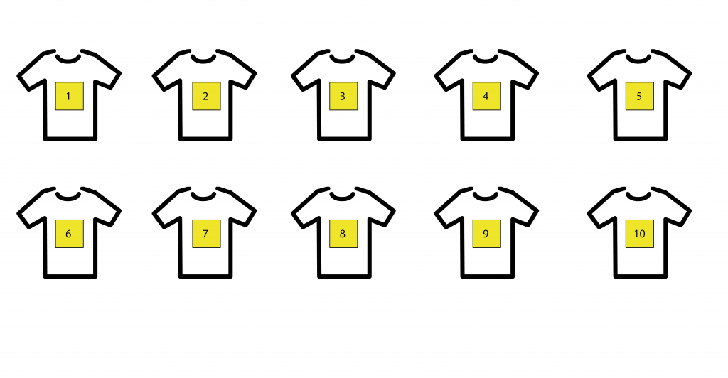The children will need to read the number that each of their teammates has on their back to the rest of their group, until everyone knows what is written on their post-it note. You could alternate between numerical representations and numbers written out in their worded form.

Then, it is a race as a team to organise themselves from smallest to largest, according to the numbers they have been assigned.

You can enlarge the teams or increase the numbers to add extra challenge.

**Place Value Game #7: Passing Practice**

Best for Year 2 or 3, and especially good for the sort of stealthy [outdoor maths activity](https://thirdspacelearning.com/blog/13-outdoor-maths-activities-early-years-year-6-plus-bonus-ages/) you can sneak in as part of a PE or general outdoors session.

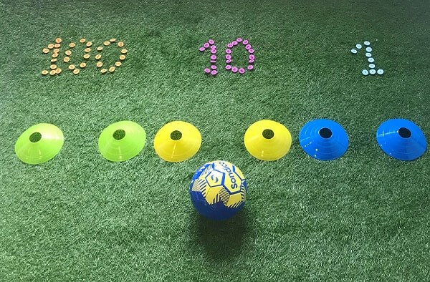Using cones from the PE cupboard, set up two or more sets of three goals. Each goal will only need two cones – each cone being a goal post – and each goal will represent a place value column: ones, tens, hundreds…)

Now give each group or team a number to achieve. For example, if you gave a team the number 385, they would need to pass the ball through the ones goal five times, then the tens goal eight times and, finally, the hundreds goal three times. Again, the game could be easily turned into a competition by pitting teams against each other to add some pace.

**Place Value Game #8: Football Kit – Roman Numeral Swaps**

We’ve done the hard work for you on this one and created some templates for this printable place value game.

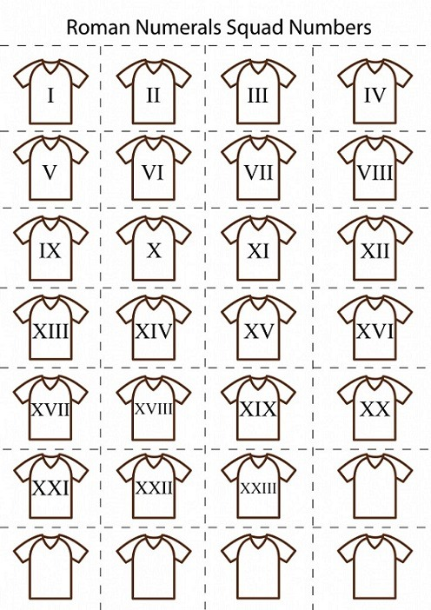Take a look at the football kit templates with shirt numbers in Roman Numeral format. (If you have a class with split footballing loyalties, there is always the option to get them to colour in the shirts in their favourite teams’ colours.) We’ve left a few empty shirts for you to use as you wish!

One child should be holding the Roman Numeral football kit cards, the other should have cards or pieces of paper with a member of their favourite football team’s squad on each card or piece of paper.

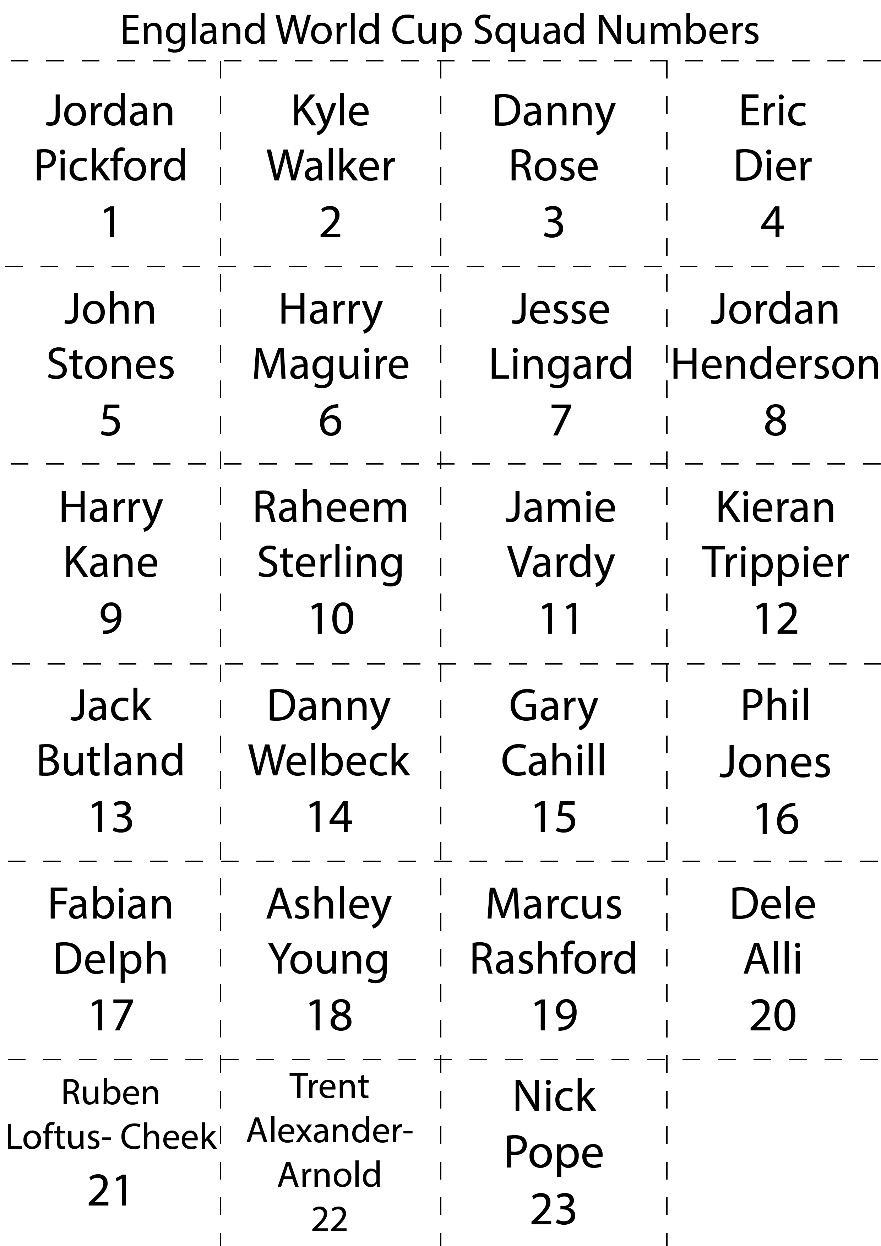For this example, we will use the heroic England squad from the 2018 World Cup. (Keen to relive those days? Take a look at our [World Cup Maths Activities](https://thirdspacelearning.com/blog/world-cup-football-maths-ideas/).)

The task here is for children to swap or match each Roman Numeral card with a player’s card with the corresponding squad number.  
  
You could challenge pairs or groups of children to match their cards, then order them from smallest to largest the fastest! (You could extend the task by asking the children to sort them in other ways too: odds and evens; square numbers; prime numbers; cube numbers.)

**Place Value Game #9: Delightful Darts**

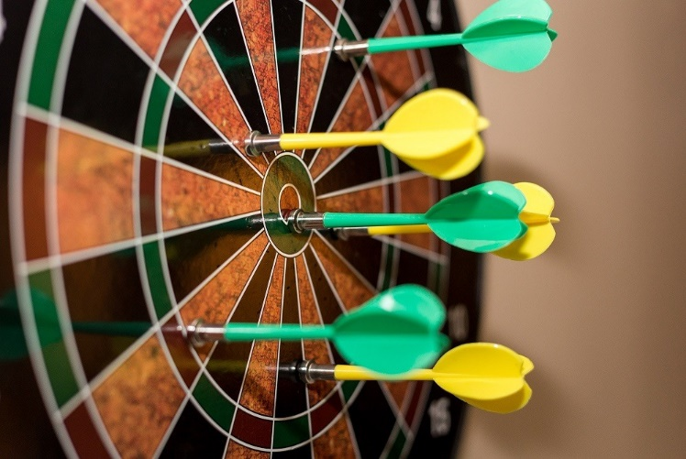*We recommend a magnetic dart board for this place value game for upper KS2; of course it works as well with real darts but they bring their own challenges to a group of Year 5s and Year 6s.*

The range of place value challenges you can set with a dart board are almost limitless. It’s also a great way to practice other [number facts](https://thirdspacelearning.com/blog/help-primary-pupils-memorise-number-facts-maths-10-tried-tested-ideas/) and [mental maths strategies](https://thirdspacelearning.com/blog/33-mental-maths-strategies-ks2-checklist/).

Here are some ideas:

* You could ask the children to work their way around the dart board in either an ascending or descending order.
* You could set them individual challenges: your next dart must have an odd value; your next throw must have a single digit value; your next throw must stick in a two-digit value area; your next throw must end in a prime number value area or have the factors 4 and 8.

It’s also a great opportunity for the children to practice their mental addition skills, two and three times tables – they need to be able to multiply by three to hit the magic 180!

**Place Value Game #10: NEW FOR 2019 – Round the Dice**

*Another simple dice-based place value game, this time tailored towards Year 2 and up! Children can roll the dice and record results as many times as you decide, but we recommend 5 or 10 rolls.*

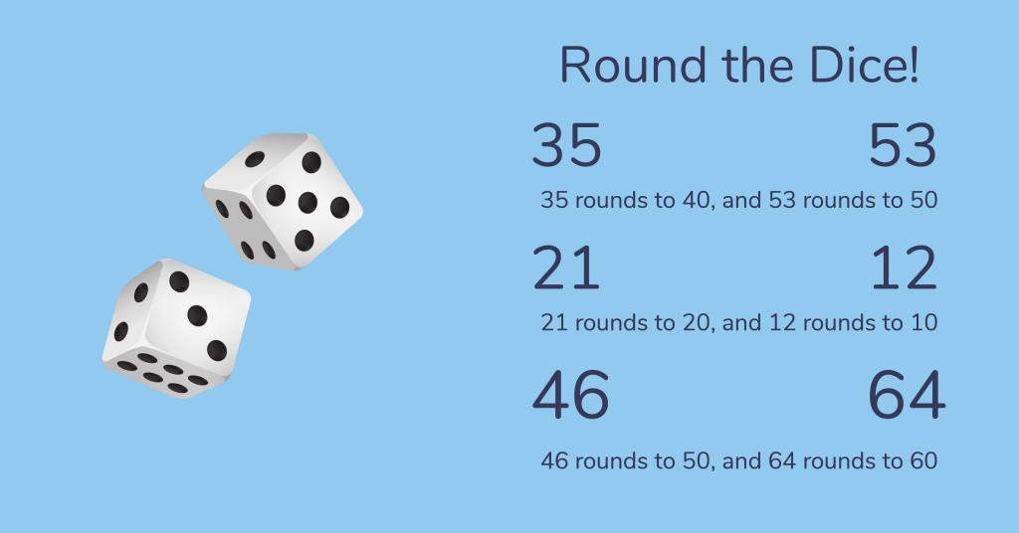Pair off the class and provide each pair with their own pair of dice. Children should roll the dice and see which two numbers land face up e.g. 3 and 5. From these two single digits, they can make two double digit numbers – in this case 35 and 53.

Have the children record their rolls, the resulting double digit numbers and what they round to, then have them roll again.

Some key questions:

* What numbers can you make?
* Will the two digit numbers round up or down?
* EXTENSION: Will any pair of double digit numbers ever round to the same multiple of ten (e.g. both round to 30). When does this happen?

**That’s our list of place value games and activities done.**

All of them can be adapted to suit the ages and abilities of children in your class. And by using them as a way into the subject you’ll find your pupils will be better able to create links between abstract numbers and real world scenarios.

Place value confidence is a crucial step in helping children to visualise number more clearly and partition mentally with greater success, as well as laying the foundations for improving mental strategies increasing the speed of mental calculations too.

Let us know if you play other [fun maths games](https://thirdspacelearning.com/blog/fun-maths-games-activities-for-kids/) in your classroom that you’d like us to share and we will include them in future posts!

It doesn’t matter whether you are teaching place value, the four operations or preparing for the SATs, it is crucial that you have strategies ready to help your pupils achieve the most they can. That’s why we’ve put together our list of [20 maths strategies that we use in our teaching to ensure every pupil makes progress](https://thirdspacelearning.com/blog/20-maths-strategies-ks2-progress/). Take a look and let us know what you think.

**Further Reading**:

* [How To Teach Place Value in Year 5 and 6 For Small Group KS2 Interventions](https://thirdspacelearning.com/blog/how-to-teach-place-value-ks2-interventions-maths-bootcamp-4/)
* [The Best Place Value Resource Ever And How to Make It! [FREE Place Value Concertina]](https://thirdspacelearning.com/blog/place-value-resource-ks1-ks2-concertina/)
* [Guide to Place Value in the KS1 and KS2 National Curriculum](https://thirdspacelearning.com/blog/quick-easy-guide-place-value-new-key-stage-1-key-stage-2-national-curriculum/)
* For Year 5 and Year 6: [75 SATs style questions on Place Value, Fractions, Addition and Subtraction](https://thirdspacelearning.com/blog/75-ks2-sats-maths-questions-place-value-fractions-decimals-addition-subtraction)