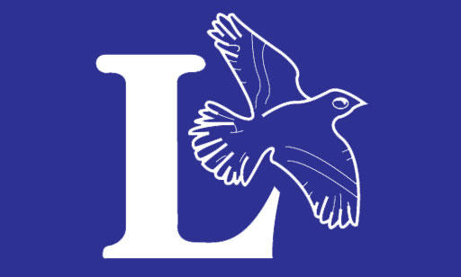
LARKRISE CURRICULUM - HISTORY
 | Autumn 1 | Autumn 2 | Spring 1 | Spring 2 | Summer 1 | Summer 2
Reception | Who they are and where they have come from |  | differences and similarities between now & the past | How their family members changed from past to present
Year 1 | My Life Story | Toys old and new | Life in Castles/Kings and Queens
Year 2 | The Great Fire of London |  |  | Marconi | Famous Explorers;  Neil Armstrong  Captain Cook
Year 3 |  | The Indus Valley | The Romans |  |  | Aboriginal Society
Year 4 | The Ancient Greeks |  |  |  | Stone age to Iron Age | Ancient Egyptians
Year 5 | Anglo Saxons and Vikings |  |  |  | Industrial Revolution | American Black History
Year 6 | WW2 |  |  |  | Tudors

